Stock Market Anomaly: Day of the

Week Effect in Dhaka Stock Exchange

This paper uses dummy variable regression and GARCH(1,1) model.

[ Dummy variable regression: A dummy variable is a numerical variable used in regression analysis to represent subgroups of the sample in your study. In research design, a dummy variable is often used to distinguish different treatment groups. In the simplest case, we would use a 0,1 dummy variable where a person is given a value of 0 if they are in the control group or a 1 if they are in the treated group. Dummy variables are useful because they enable us to use a single regression equation to represent multiple groups.]

[Generalized AutoRegressive Conditional Heteroskedasticity (GARCH) is **a statistical model used in analyzing time-series data where the variance error is believed to be serially auto correlated**. GARCH models assume that the variance of the error term follows an autoregressive moving average process]

Result: “Results also indicate that the conditional mean return tends to shift to the positive direction on Thursdays and negative direction on Sundays and Mondays.”

**In short: Before holiday, people sell short. Means, they want to sell stocks at a lower price(probably for safety and returning to family type reasons). So, it is a good opportunity to buy.**

### 3.2 Data

Data used in the study include daily closing prices of DSE indices such as DSE all share prices index (DSI), DSE general index (DGEN) and DSE 20 index DSE 20)for a period of 04.09.2005-08.10.2008. All the data has been collected from the DSE library.

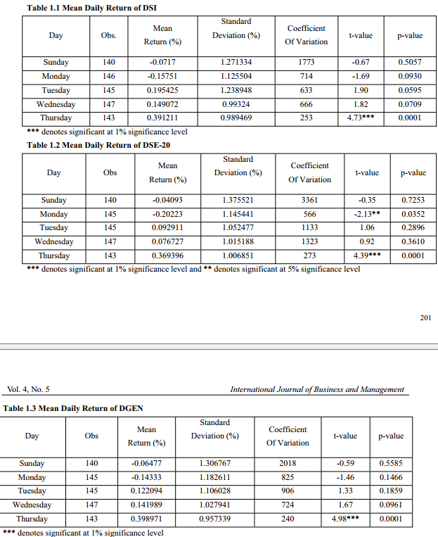

Same types of pattern also observed

Paper: The Impact of Religious Experience on Financial Markets

